**SQL QUERIES**

**KPI**

**----WHOLE TABLE VIEW----**

select * from pizza_sales;

**----TOTAL REVENUE----**

select SUM(total_price) as TOTAL_REVENUE from pizza_sales;

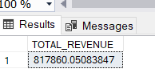

**----AVERAGE ORDER VALUE----**

select SUM(total_price) / COUNT(DISTINCT(order_id)) as AVERAGE_ORDER_VALUE from pizza_sales;

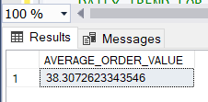

**----TOTAL PIZZA SOLD----**

select SUM(quantity) as TOTAL_PIZZA_SOLD from pizza_sales;

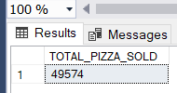

**----TOTAL ORDERS----**

select COUNT(DISTINCT(order_id)) as TOTAL_ORDERS from pizza_sales;

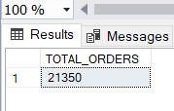

**----AVERAGE PIZZA PER ORDER----**

select CAST(CAST(SUM(quantity) AS decimal(10,2)) / CAST(COUNT(DISTINCT(order_id)) AS DECIMAL(10,2)) AS decimal(10,2) )as AVERAGE_PIZZA_SOLD from pizza_sales;

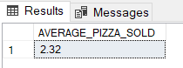

**----DAILY TREND FOR TOTAL ORDERS----**

select DATENAME(DW,order_date) as ORDER_DAY , COUNT(DISTINCT(order_id)) as TOTAL_ORDERS

from pizza_sales

GROUP BY DATENAME(DW,order_date);

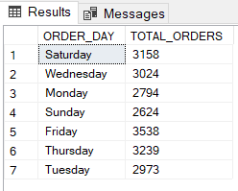

**TREND FOR TOTAL ORDERS**

**----HOURLY TREND FOR TOTAL ORDERS----**

select DATEPART(HOUR, order_time) as ORDER_HOURS , COUNT(DISTINCT(order_id)) as TOTAL_ORDERS

from pizza_sales

GROUP BY DATEPART(HOUR, order_time)

ORDER BY DATEPART(HOUR, order_time);

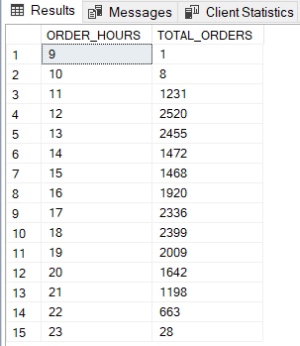

**---MONTH WISE IF YOU WANT----**

select pizza_category , SUM(total_price)*100 / (select SUM(total_price) from pizza_sales) as TOTAL_SALES

from pizza_sales

WHERE MONTH(order_date)=1

GROUP BY pizza_category;

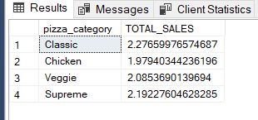

**SALES BY PIZZA CATEGORY**

**---% OF SALES BY PIZZA CATEGORY---**

select pizza_category , SUM(total_price)*100 / (select SUM(total_price) from pizza_sales) as TOTAL_SALES

from pizza_sales

GROUP BY pizza_category;

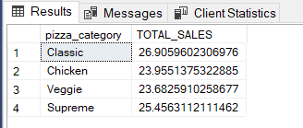

**----% OF SALES BY PIZZA SIZE---**

select pizza_size , CAST(SUM(total_price)*100 / (select SUM(total_price) from pizza_sales) AS DECIMAL(10,2)) as TOTAL_SALES

from pizza_sales

GROUP BY pizza_size

ORDER BY pizza_size;

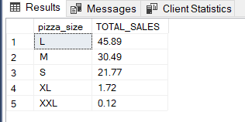

**----TOTAL PIZZA SOLD BY PIZZA CATEGORY----**

select pizza_category , SUM(quantity) as TOTAL_PIZZA_SOLD

from pizza_sales

GROUP BY pizza_category ;

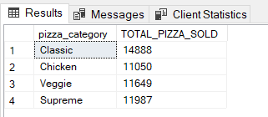

**BEST AND WORST SELLER PIZZA**

**----TOP 5 BEST SELLER BY TOTAL PIZZA SOLD----**

select TOP 5 pizza_name, SUM(quantity) as TOTAL_PIZZA_SOLD

from pizza_sales

GROUP BY pizza_name

ORDER BY TOTAL_PIZZA_SOLD DESC;

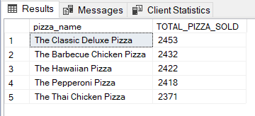

**----BOTTOM 5 WORST SELLER BY TOTAL PIZZA SOLD----**

select TOP 5 pizza_name , SUM(quantity) as TOTAL_PIZZA_SOLD

from pizza_sales

GROUP BY pizza_name

ORDER BY TOTAL_PIZZA_SOLD;

